**EMPOWERING HEALTHY FOOD PRODUCTION OF "SOY BOB" SOY MILK FOR SMALL BUSINESS GROUPS IN MANGUNHARJO TEMBALANG SEMARANG**



Fatimah Fatimah1; Siti Masrochah2; Yeti Kartikasari 3; Veny Nur Aini 4; Dimas Prakoso 5; Ria Ambarwati 6

*1Radiodiagnostic and Radiotherapy Technic Department, Poltekkes Kemenkes Semarang, Indonesia*

*2Radiodiagnostic and Radiotherapy Technic Department, Poltekkes Kemenkes Semarang, Indonesia*

*3Radiodiagnostic and Radiotherapy Technic Department, Poltekkes Kemenkes Semarang, Indonesia*

*4Radiodiagnostic and Radiotherapy Technic Department, Poltekkes Kemenkes Semarang, Indonesia*

*5Radiodiagnostic and Radiotherapy Technic Department, Poltekkes Kemenkes Semarang, Indonesia*

*6Nutrition Department, Poltekkes Kemenkes Semarang, Indonesia*

|  |
| --- |
| Corresponding author: Fatimah Fatimah  Email: fatimah_yunaeza@yahoo.com |

**ABSTRACT**

This Soy Bob product is different from the soy milk that is usually circulated and known to the public. On the other hand, all works do not have patents or copyrights with their unique characteristics, as well as packaging management and marketing efforts. Likewise, this small soy milk culinary business is managed traditionally, both packaging and not having an AKG value, expired, as well as marketing efforts. Therefore, **the aim** of this community service is expected to be to strengthen the quality of small business products in the Mangunharjo Tembalang area. The population for this activity was residents of RW V, Mangunharjo Tembalang Village. **The method** used in this activity was a training approach, followed by program implementation by assisting certification, licensing and there was an evaluation at each stage will be carried out to obtain feedback and further improvement efforts. **The results and discussions** of this activity were the awareness and understanding of visitors regarding health and the importance of consuming soy milk and the NIB registration for Soy Bob soy milk had been registered. In addition, the NIB and PIRT registration guide for Small Businesses had been compiled, Soy Bob product booklets and books had been copyrighted. **The conclusion** from this activity was that it could be carried out well. There was increasing public awareness of the importance of "Soy Bob" soy milk for health. For this reason, it is necessary to increase the motivation of the assisted villages to produce other healthy food and drink products to improve health as well as to increase the income of the assisted villages.

Keywords: soy bob; soy milk

**Introduction**

**(*Pendahuluan)***

The Durenan Indah Tourism Awareness Group (Pokdarwis) as one of the partners fostered by the Community Service Department of Radiodiagnostic Engineering and Radiotherapy starting in 2020, has developed Small Business of Soy Bob as an active UKM that produces soy milk, which has been regularly producing soy milk products for the last 5 years and already has community customers in the Tembalang area and around Semarang. At certain events, especially local product development, Soy Bob soy milk has also become local wisdom's mainstay product as a refreshing drink and also a typical commodity to support healthy tourism. Likewise, in the pandemic era where people need to maintain their immune system, Soy Bob soy milk has also become the public's choice of consumption to maintain their immunity and health. Therefore, to develop this healthy living movement, it is necessary to develop soy bob soy milk products both from administrative, hygienic, food technology and product certification aspects so that they are worthy of becoming healthy product commodities that can be consumed by local and global communities as they develop. With the innovation of various flavors and toppings, this Soy Bob product is different from the soy milk that is usually circulated and is known by the public and internationally. On the other hand, all works do not have patents or Small Business Groups (UKM) with their unique characteristics, as well as packaging management and marketing efforts. Likewise, this Soy Milk culinary UKM is managed traditionally, whether the packaging or does not have an AKG value, has expired, as well as marketing efforts. Therefore, through this community service, it is hoped that it can strengthen the quality of healthy products in the Mangunharjo Tembalang area.

Generally, people use soybeans as a source of nutrition and protein, because they are cheap and easy to obtain. Soy milk is an effort to improve nutrition, because it contains animal and vegetable protein [1]. According to other studies, soybeans provide health benefits, reducing cardiovascular disease, reducing menopausal symptoms, reducing weight, arthritis and brain function.[8] Soy contains phytochemicals including isoflavones, saponins, and phy-tosterol to improve health, soy milk is an ideal cholesterol-free supplement for cardiovascular [2]. Fermented soy milk is good as an anti-ACE, anti-oxidative. The health benefits in soy are attributed to isoflavonoids which can support chemoprevention of diseased cells and also contain the main phenolic phytochemicals found in milk [7].

The objectives of this Community Service Activity are:

Providing assistance to Healthy Soy Bob Soy Milk UKMs in Pokdarwis Durenan Indah for hygienic and attractive packaging management.

Provide assistance to Healthy Soy Bob Soy Milk UKMs in Pokdarwis Durenan Indah to obtain knowledge and business permits, including: NIB, P-IRT, and Halal.

Motivate the community to be more creative and innovative in marketing Soy Bob Soy Milk both offline and online to improve consumer health (local elderly in particular) and the production of UKM Pokdarwis Durenan Indah.

Developing lecturers' abilities so that they continue to increase their creativity so that it can be realized in the development of knowledge and as one of the implementations of the Tri Dharma of Higher Education.

**Methods**

**(*Metode Penelitian)***

The population for this activity were residents of RW V, Mangunharjo Tembalang Village. The method used in this activity was a training approach, followed by program implementation by assisting certification and licensing. Each time stage an evaluation had been carried out to obtain feedback and further improvement efforts.

Evaluation was carried out through monitoring each activity through (1) Evaluation of the results of Training Implementation; (2) Evaluation of the provision of healthy tourism assisted village facilities in accordance with health standards; (3) Assessment of success indicators: seen from cadres in implementing health and safety aspects; (4) Evaluation of visitor attendance in the Soy Bob Soy Milk program as a healthy drink.

**Results and Discussion**

**(*Hasil dan Pembahasan)***

1)Preparation

Arrangement of permits for the Empowerment of Healthy Food Production of "Soy Bob" Soy Milk for Small Business Groups in Mangunharjo Village, Meteseh, Tembalang District on 4 - 18 May 2023

Location survey activities, data collection and potential for UKM/UMKM in the Healthy Tourism Village fostered area, especially soy milk products on May 19 - June 3 2023. Determination of activity locations and implementation times for UKM/UMKM activities in the Healthy Tourism Village assisted area in Meteseh, Tembalang sub-district from June to with August.

Technical coordination with local officials on May 19 – June 3 2022. Technical coordination with representatives of assisted village administrators to determine the implementation time, location of activities and equipment needed starting June 4.

2) Implementation

Healthy Culinary Training for Soy Milk UMKM Pokdarwis Durenan Indah Mangunharjo includes: Processing Soy Milk, Determining expiration dates, Frozen Product Training, Packaging Training.

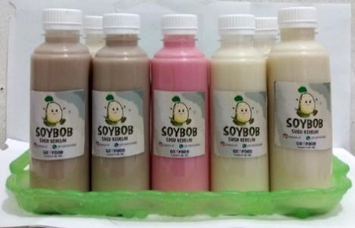

Figure 1. Packaging: affixing the sticker/brand and expiration date to the bottles

Assistance with NIB administration registration and Explanation of PIRT Certificates and Halal Certificates.

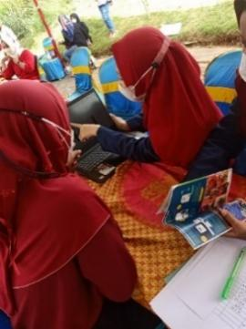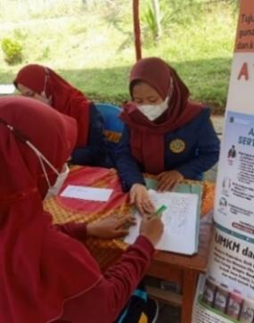

Figure 2. Online administration registration

Assistance with the implementation of promotion and marketing of Soy Bob soy milk products

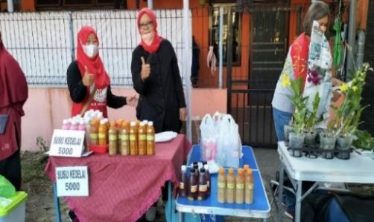

Figure 3. Product promotion and marketing training

Food Expo for Soy Bob soy milk products together with other healthy food UMKM which were busy with the people of Mangunharjo Subdistrict and coincided with the Republic of Indonesia's Independence Day celebrations.

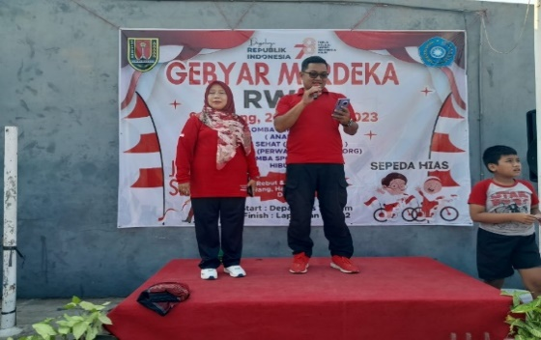

Figure 4. Opening of the expo event

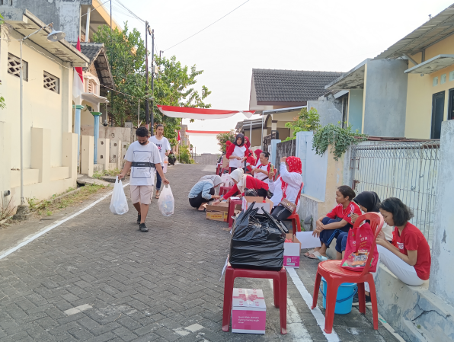

Figure 5. Preparation for sales of healthy food and beverage products

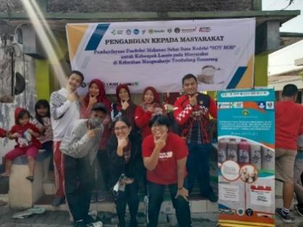

Figure 6. Soy Bob soy milk community service stand

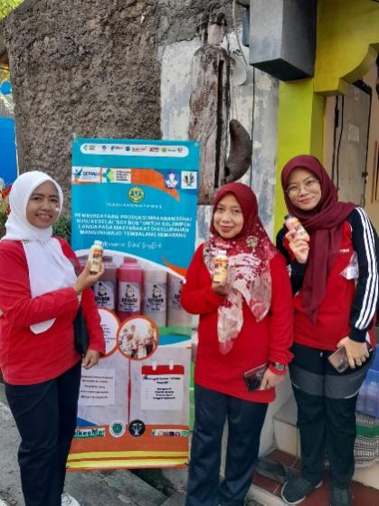

Figure 7. Soy Bob Product Marketing

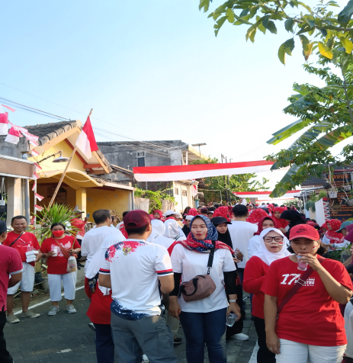

Figure 8. Implementing a healthy lifestyle by walking

Counseling about the importance of soy milk to the Mangunharjo Village Community and health checks.

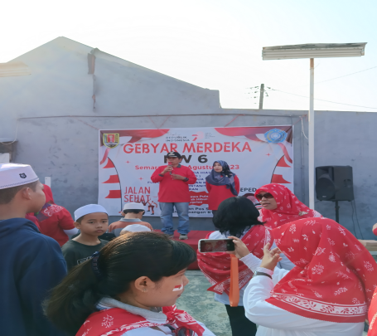

Figure 9. Resource person from Durenan Indah thematic village by Mr. Pramujiarto, SE.MM.Par

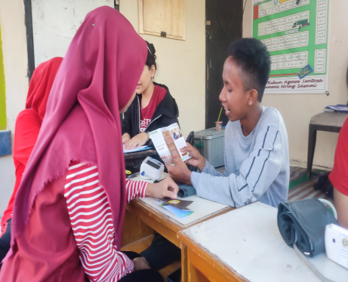

Figure 10. Education about the importance of soy milk for health

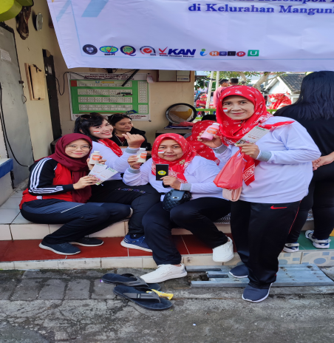

Figure 11. Distribution of Booklets

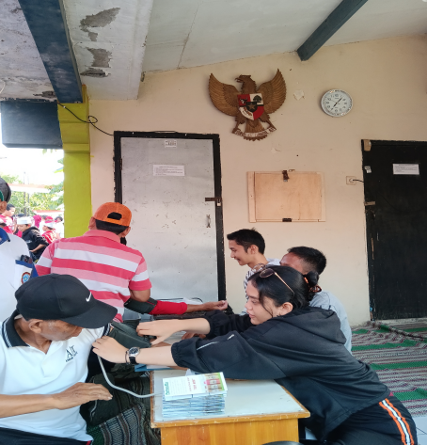

Figure 12. Free health check

Preparation of the final national service report is prepared at the Ministry of Health's Polytechnic, Semarang, after the entire series of activities have been carried out.

3) Evaluation

Evaluation is carried out through monitoring indicators of the success of the Assisted Villages as seen from the achievements or outputs produced by the National Service, including:

Visitors' interest in Soy Bob soy milk and visitors' understanding of health and the importance of consuming soy milk can be seen in the following pre-test and post-test graphs:

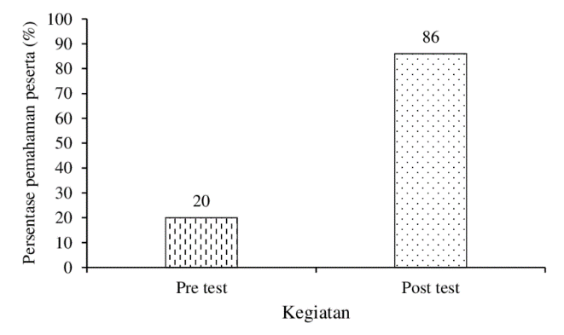

Figure 13. Graph of Development of Understanding

The NIB has been registered for Soy Bob soy milk belonging to Mr. Hanto, a resident of Mangunharjo sub-district:

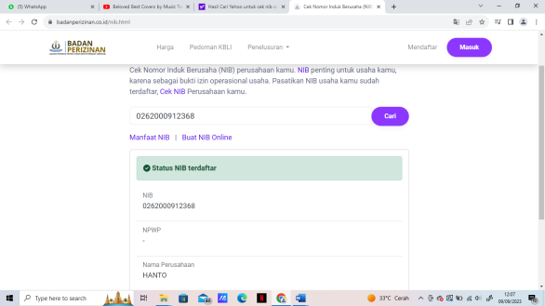

Figure 14. A Small Business Group that already has NIB

There are several guidelines related to licensing and Soy Bob which are very useful for the community as follows:

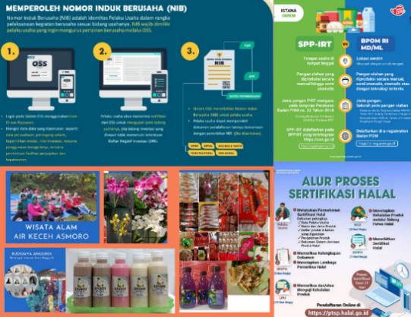

Figure 15. NIB and PIRT registration guide

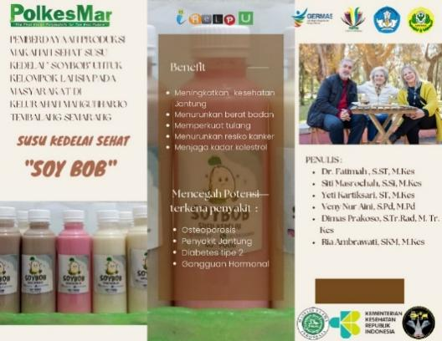

Figure 16. Product Booklet

The book in copyright (HKI) is about the process of making a healthy drink, namely Soy Bob soy milk which is made from real soybeans and processed home-made.

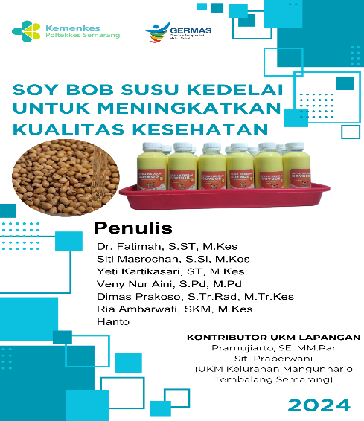

Figure 17. Soy Bob HKI Book

**Conclusion**

***(Simpulan)***

The conclusion of the activity of Empowering the Production of Healthy Soy Milk "Soy Bob" Soy Milk for Small Business Groups in Mangunharjo Subdistrict, Tembalang, Semarang, was that it could be implemented well. This could be seen in increasing public awareness and understanding of the importance of "Soy Bob" soy milk for health. Apart from that, the availability of several guidelines and the implementation of several activities had proven to have strengthened the quality of healthy products in the Mangunharjo Tembalang area.

For this reason, increasing the productivity of assisted villages needs to be further motivated, namely by training on other healthy food and drink products. Apart from improving health, this activity can also increase the income of the target village.

**References**

***(Daftar Pustaka)***

1. Wiryani Arianty, N., & Masyhura, M. (2019, October). Strategi Pemasaran Susu Kedelai Dalam Upaya Meningkatkan Pendapatan Keluarga. In Prosiding Seminar Nasional Kewirausahaan. 2019;1(1): 257-264.
2. Dharma RaflesiaJurnal Ilmiah Pengembangan dan Penerapan IPTEKS Vol. 18, No. 02, Desember, 2020, pp. 259 - 268
3. Cahyono, A. D. Manfaat susu kedelai sebagai terapi penurun kadar glukosa darah pada klien diabetes mellitus (Study eksperimental di poli penyakit dalam RSUD Pare Kabupaten Kediri tahun 2010). J Akademi Keperawatan Pamenang, 2011;4, 28-37. [https://mopolayio.fe.ung.ac.id/index.php/mopolayio diakses pada tanggal 19/11/2022](https://mopolayio.fe.ung.ac.id/index.php/mopolayio%20diakses%20pada%20tanggal%2019/11/2022)
4. Katalog Dalam Terbitan. Kementerian Kesehatan RI Indonesia. Kementerian Kesehatan RI. Direktorat Jenderal Kesehatan Masyarakat Tiga Tahun
5. Germas: Lessons Learned Jakarta: Kementerian Kesehatan RI. 2019
6. Puspitasari, E. Pengaruh pemberian susu kedelai terhadap peningkatan produksi asi pada ibu nifas di rb bina sehat bantul. Jurnal Kebidanan, 2018*7*(1), 54-60.
7. Sutrisno, S. Pemberdayaan Anggota Majelis Taklim Melalui Usaha Susu Kedelai Dan Nugget. Comvice: Journal of community service, 2018;2(2), 21-28.
8. Wimpertiwi, D., Sasongko, A. H., & Kurniawan, A. Konsep Business Process ReenginEering untuk Memperbaiki Kinerja Bisnis Menjadi Lebih Baik: Studi Kasus Perusahaan Susu Kedelai “XYZ”. Binus Business Review, (2014) 5(2), 658-668.
9. Sandy W.T., Tata Kelola Administrasi Keuangan Sederhana untuk UMKM dan Kelompok Usaha Bersama. My Journey are so Beautiful. Link <https://widytaurus.wordpress.com/2017/11/16/tata-kelola-administrasi-keuangan-sederhana-untuk-umkm-dan-kelompok-usaha-bersama/> diakses pada tanggal 20/11/2022
10. Noholo S., Lukum A. Pengelolaan Administrasi dan Pencatatan Akuntansi Bagi Usaha Mikro Kecil Menengah. Mopolayio : Jurnal Pengabdian Ekonomi, 1(1): 11- 2021. Link [https://mopolayio.fe.ung.ac.id/index.php/mopolayio diakses pada tanggal 19/11/2022](https://mopolayio.fe.ung.ac.id/index.php/mopolayio%20diakses%20pada%20tanggal%2019/11/2022)
11. Ade Raselawati, Pengaruh Perkembangan Usaha Kecil Menengah Terhadap Pertumbuhan Ekonomi Pada Sektor UKM Di Indonesia, Skripsi, (Fakultas Ekonomi dan Bisnis, Universitas Islam Negeri Syarif Hidayatullah: Jakarta, 2011), hal. 12