Comprehensive Overview of Nurses' Knowledge and Skills in Documenting Nursing Care Accurately and Efficiently at Community Health Centres

Tri Suwarto¹, Fitriana Kartikasari¹, Jeki Pornomo ²

¹Prodi Profesi Ners, Fakultas Ilmu Kesehatan, Universitas Muhammadiyah Kudus, Indonesia
² Prodi S1 Administrasi Rumah Sakit, Fakultas Ilmu Kesehatan, Universitas Muhammadiyah Kudus, Indonesia
Corresponding author: jeki.purnomo@umkudus.ac.id

ABSTRACT

Proper documentation functions as an accurate medical record, legal proof, communication tool among healthcare professionals and a foundation for evaluating and improving services, making nurses' ability to document nursing care accurately and also efficiently vital for research and development. This research aims to provide a comprehensive overview of the knowledge, skill levels of nurses in community health centres in documenting nursing care accurately and efficiently. This quantitative descriptive research use a total sampling approach on all nurses working in community health centres in one district in Indonesia. A questionnaire instrument is used to assess nurses' Knowledge while the skill observation is conducted by using a checklist to assess nurses' practical skills in performing nursing care documentation, including completeness, timeliness, use of standard terms, neatness of documentation. Data is analysed to examine the distribution of knowledge, skill levels possessed by the nurses. Results indicate nurses possess high levels of theoretical knowledge. However, practical skills often lag behind, with several skill areas requiring reinforcement. In assessment, significant gaps exist in biopsychosocial-spiritual data collection skills compared to nurses' knowledge. In diagnosis, data analysis and interpretation skills need improvement despite adequate nursing knowledge. In planning, nurses demonstrate difficulties in formulating action plans based on specific objectives. Nursing intervention implementation, such as health education for families and self-hygiene training, also shows disparities between knowledge and skills. Evaluation of patient and family capabilities shows balanced results. However, nursing care documentation still requires improvement in recording skills. Proposed recommendations include developing continuous training programmes, fostering interdisciplinary collaboration, enhancing family education, improving documentation skills, conducting regular evaluations of nurses' knowledge and skills.

Keywords:
Nursing Knowledge and Skills; Anamnesis and Data Confirmation; Diagnosis Formulation; Care Planning and Involvement; Evaluation of Nursing Interventions; Documentation Standards; Reinforcement and Motivation

BACKGROUND
Nursing care documentation constitutes a vital component of healthcare services, particularly in primary health facilities such as community health centres. Proper documentation serves as an accurate medical record, legal evidence, communication tool among healthcare professionals and basis for service evaluation and improvement. Clear and comprehensive documentation adhering to standard operating procedures (SOPs) directly impacts patient safety also quality of care provided. Nurses' ability to document nursing care accurately and efficiently becomes a crucial aspect for research and improvement.
In Indonesia, the community health centre-based healthcare system plays a strategic role in primary healthcare provision. As the frontline of public health services, community health centres function not only in curative care but also in preventive, promotive services. In service delivery, nurses often become the most involved healthcare professionals in the nursing care process, from assessment to medical intervention implementation. This role positions nurses as key to successful nursing care documentation, ultimately affecting the quality of service received by patients.
However, daily practice reveals various obstacles in optimal documentation implementation at community health centres. Several studies mention lack of knowledge about documentation standards, time constraints and high workload as frequent inhibiting factors for nurses in correctly documenting nursing care. Additionally, manual recording habits can affect consistency, accuracy in information recording, especially in community health centres that have not adopted electronic documentation systems. This condition underscores the importance of further assessment of nurses' knowledge, skill levels related to documentation, as a basis for designing appropriate interventions to improve nursing care documentation quality at community health centres.
In the regulatory context, the Regulation of the Minister of Health of the Republic of Indonesia Number 49 of 2013 concerning Nursing Competency Standards provides clear guidance on nurses' roles, responsibilities in documenting nursing care. This standard emphasises the importance of documenting every action performed by nurses, both medical, non-medical interventions, completely, accurately and timely. Furthermore, the Regulation of the Minister of Health of the Republic of Indonesia Number 269/MENKES/PER/III/2008 concerning Medical Records also states that medical records are official documents that must be filled out correctly, maintained systematically to ensure healthcare service quality. This regulation further reinforces the importance of documentation as part of professional nursing practice that must be mastered by every nurse at various levels of healthcare services including community health centres.
Previous research highlighting nursing care documentation in community health centres tends to show varied results. For example, a research conducted by Fatimah (2019) in Central Java community health centres found that 60% of nurses in these centres still experienced difficulties in understanding, applying established documentation standards. These difficulties were largely due to lack of training, minimal socialisation regarding the importance of good documentation in nursing care. A similar research conducted by Wahyuni (2020) in South Sulawesi also showed that nurses' documentation skills in community health centres tended to be less than optimal, with most nurses relying on inefficient, time-consuming manual recording.
These studies illustrate that although nurses in community health centres have significant responsibilities in the documentation process, there remains a considerable gap between expectations, reality in the field. This indicates the need for more systematic efforts to improve nurses' knowledge and skills, both through continuous training, implementation of a more integrated documentation system. This research is expected to provide more in-depth information on the extent of nurses' knowledge, skills in documenting nursing care as well as factors influencing the effectiveness of such documentation.
Nurses' knowledge related to nursing care documentation encompasses their understanding of definitions, objectives, principles underlying documentation practices. Ideal nursing care documentation should reflect the nursing process from assessment, planning, implementation, to evaluation, in accordance with the S-O-A-P (Subjective, Objective, Assessment, Plan) approach. Nurses' understanding of the importance of recording clear, detailed information, as well as applying standards in the recording process, is an integral part of their professional responsibilities. Meanwhile, nurses' skills in performing documentation refer to the technical ability to record nursing care data completely, timely, neatly. These skills also include nurses' ability to use standard terms, follow predetermined documentation formats, maintain consistency in recording.
In the context of community health centres, the effectiveness of nursing care documentation has broad impacts. It not only affects the quality of services received by patients but also plays a role in evaluating the performance of the community health centre itself. Good documentation can be used as a tool to monitor patient progress, evaluate the effectiveness of interventions performed, serve as a basis for further clinical decision-making. Additionally, in certain situations, documentation can also function as evidence in legal aspects, especially when disputes arise related to healthcare services.
However, the challenges faced by nurses in community health centres in documenting nursing care cannot be ignored. High workload, time constraints, often limited available resources become inhibiting factors affecting documentation quality. Furthermore, low levels of digital literacy in some community health centres also become a separate obstacle, especially in implementing electronic documentation systems considered more efficient and accurate. Therefore, it is important for community health centre management to provide adequate support in the form of training, supervision, provision of adequate facilities and infrastructure to support optimal documentation practices.

OBJECTIVE
This research aims to comprehensively describe the level of knowledge, skills of nurses in community health centres in documenting nursing care accurately and efficiently. Using a quantitative descriptive approach, this research will analyse the distribution of nurses' knowledge, skills in various community health centres, identify factors influencing documentation effectiveness. The results of this research are expected to form the basis for designing appropriate training programs, interventions and provide recommendations for improving documentation systems in community health centres, thereby enhancing the quality of nursing care provided to patients.

METHODS
This quantitative descriptive research use a total sampling approach on all nurses working in community health centres in one district in Indonesia. A questionnaire instrument is used to assess nurses' understanding of standards, guidelines, principles of accurate and efficient nursing care documentation. Skill observation is conducted using a checklist to assess nurses' practical skills in performing nursing care documentation, including completeness, timeliness, use of standard terms and neatness of documentation. Data is analysed to examine the distribution of knowledge and skill levels possessed by the nurses. Descriptive statistical analysis such as frequency, percentage, mean, standard deviation is used to describe nurses' knowledge and skill levels. Data will be presented in the form of graphs supported with descriptive narratives depicting the distribution of nurses' knowledge and skills in various community health centres.

RESULTS
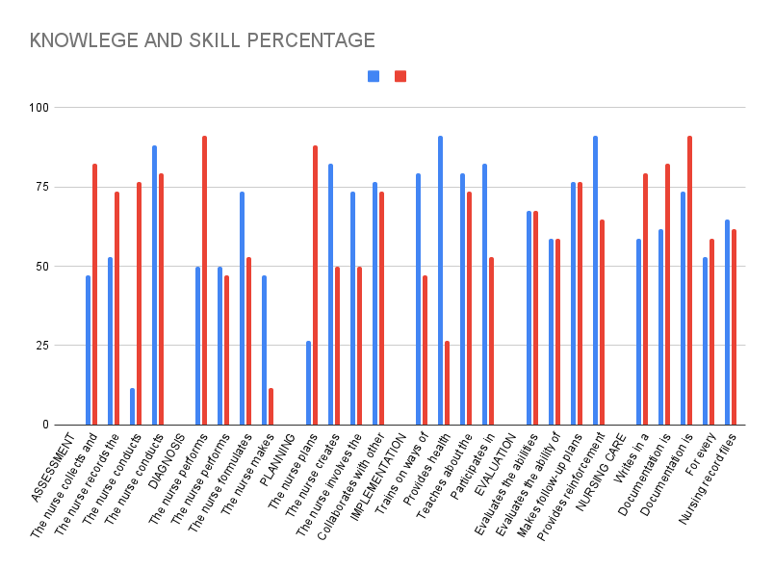
The diagram illustrates the comparative analysis of nursing knowledge and skills in various aspects of patient care. This visual representation provides insight into the gaps between theoretical knowledge and practical skills among nurses. It highlights the areas where further training and improvement are necessary to enhance the overall quality of nursing care. The data depicted in the chart serves as a foundation for understanding the competencies of nurses in executing essential tasks in patient management, thereby guiding future educational interventions and professional development initiatives.

Assessment

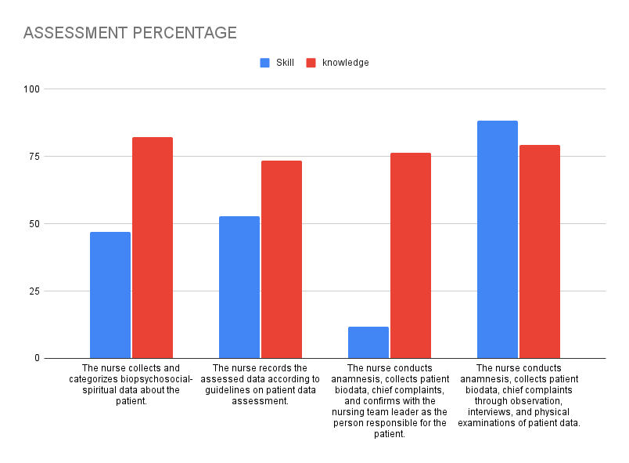
- Nurses gather biopsychosocial-spiritual patient data. Their knowledge in this domain surpasses their practical skills, indicating a need for enhanced skill development.
- Patient data documentation adheres to established guidelines. Nurses' theoretical understanding of documentation protocols exceeds their practical application, necessitating improved implementation.
- Nurses conduct patient anamnesis, collect biodata, record primary complaints, confirming with the nursing team leader. Their anamnesis skills approach their theoretical knowledge, yet communication with team leaders could be enhanced.
- Patient anamnesis involves observation, interviews and physical examinations. Nurses' theoretical grasp of these methods surpasses their practical execution, suggesting a need for additional hands-on training.

Diagnosis

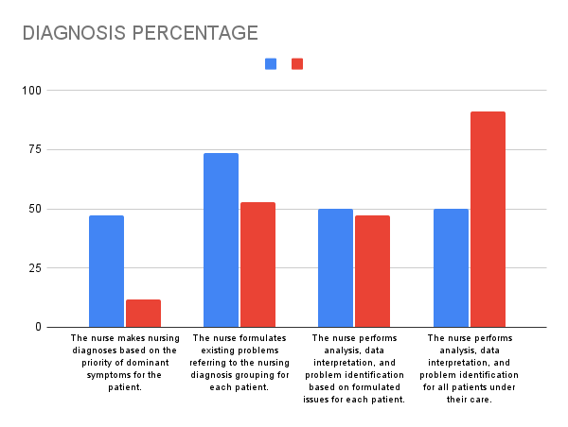
- Nurses analyse data, interpret findings and identify patient issues for all cases. Their analytical knowledge aligns with their practical skills, both at satisfactory levels with room for improvement.
- Patient-specific analysis, data interpretation, problem identification based on formulated issues occur for each case. Analytical skills lag behind theoretical knowledge, necessitating enhanced critical analysis training.
- Nurses formulate existing issues referencing nursing diagnosis groupings for each patient. Theoretical understanding of diagnosis groupings significantly exceeds practical application skills, requiring immediate attention.
- Nursing diagnoses prioritise dominant symptoms. Theoretical knowledge surpasses practical skills in prioritisation, indicating a need for training in accurate and efficient symptom identification.
Planning

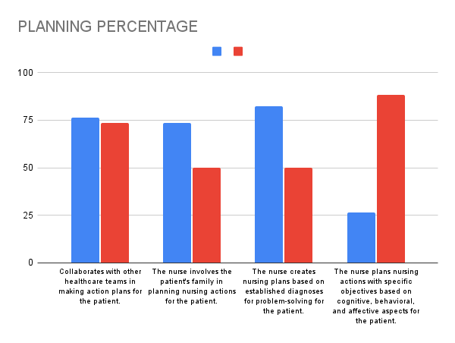
- Nurses plan interventions with specific cognitive, behavioural and affective aspects. Skills in objective-based planning lag behind theoretical knowledge, suggesting a need for enhanced cognitive and behavioural training.
- Care plans address established patient issues. Theoretical problem-solving knowledge exceeds practical care planning skills based on established diagnoses, necessitating skill reinforcement.
- Nurses involve patients' families in care planning. Family involvement skills significantly lag behind theoretical knowledge, requiring more intensive collaborative approaches.
- Interdisciplinary collaboration occurs in patient care planning. Theoretical knowledge and practical skills in interdisciplinary cooperation show balance, with potential for further practical skill enhancement.

Implementation

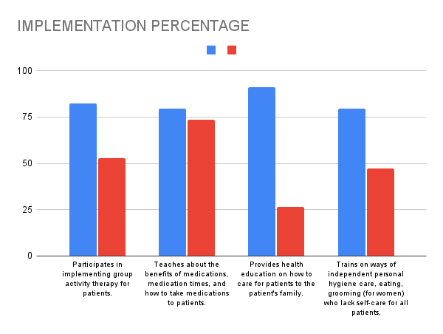
- Nurses train patients in self-care hygiene. Practical skills in patient hygiene education fall short of theoretical knowledge, indicating a need for enhanced training techniques.
- Health education is provided to patients' families regarding patient care. Implementation skills lag behind theoretical knowledge, yet remain at adequate levels.
- Nurses educate patients on medication benefits, schedules, administration methods. Theoretical knowledge excels, yet practical teaching skills show room for improvement.
- Nurses participate in group activity therapies. Practical implementation skills surpass theoretical knowledge, demonstrating well-internalised field practices.

Evaluation

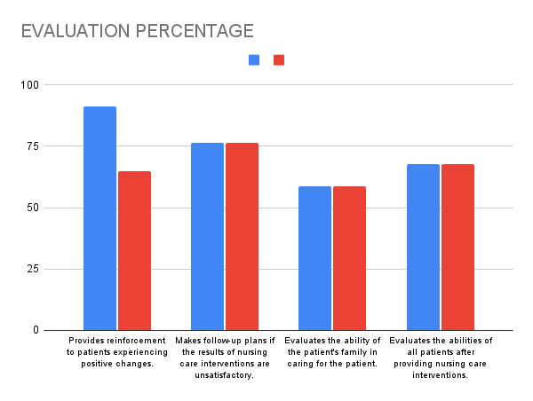
- Nurses evaluate all patients' abilities post-intervention. Evaluation skills balance with theoretical knowledge, yet more systematic evaluation approaches could strengthen intervention outcomes.
- Nurses assess families' patient care capabilities. Practical evaluation skills lag behind theoretical knowledge, necessitating improved family collaboration for optimal outcomes.
- Follow-up plans are created for unsatisfactory care outcomes. Plan development skills require enhancement, despite adequate theoretical knowledge.
- Nurses provide patient reinforcement for positive changes. Reinforcement skills fall below theoretical knowledge levels, indicating a need for improved interpersonal skill development.

Nursing Care Documentation

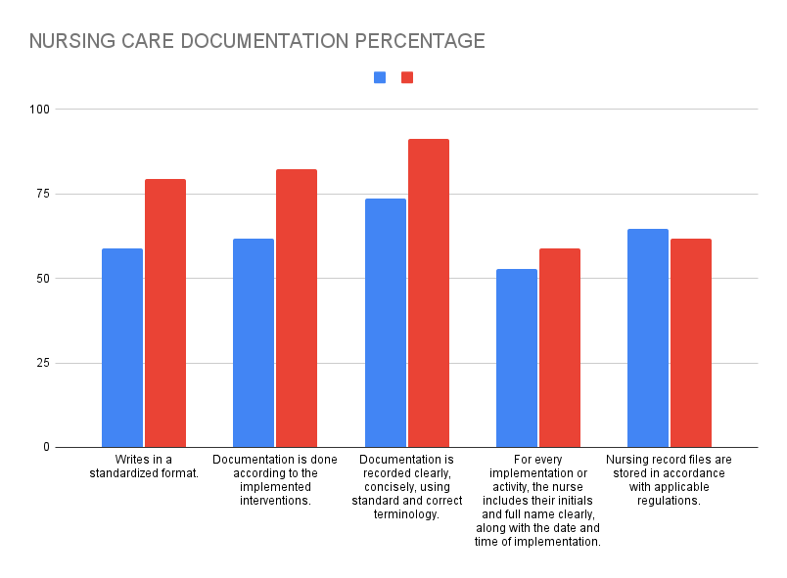
- Documentation adheres to standardised formats. Practical documentation skills require improvement, despite good theoretical format knowledge. Stricter documentation procedures are necessary.
- Documentation reflects implemented interventions. Implementation documentation shows disparity between good theoretical knowledge and practical skills requiring reinforcement for improved recording accuracy.
- Documentation employs clear, concise, standardized and correct terminology. Practical skills in using standard, clear terminology lag behind theoretical knowledge. Continuous documentation training should be intensified.
- Nurses include initials, name, date, time for each implementation or activity. Skills in recording essential details are adequate, with room for improvement in recording discipline.
- Nursing records are stored according to prevailing regulations. Record storage practices show balance between knowledge and skills, with potential for enhanced understanding of storage procedures.

DISCUSSION

Assessment
Nursing assessment constitutes a fundamental step in patient care. It involves the collection and categorisation of biopsychosocial-spiritual patient data. A significant disparity exists between nurses' theoretical knowledge and practical skills in this domain. Nurses demonstrate high theoretical understanding. Their practical skills require enhancement. Lazzari et al. (2021) and Vahidi et al. (2023) emphasise the critical nature of developing practical skills to ensure data accuracy and relevance.
Nurses' knowledge of data recording protocols surpasses their practical implementation skills. This discrepancy indicates a need for reinforced practical training to meet established standards. Kossan et al. (2022) and Green et al. (2020) corroborate these findings. They stress the importance of documentation skill training.
Anamnesis processes, including biodata collection and primary complaint identification, show satisfactory skill levels. Communication with team leaders presents opportunities for improvement. Enhanced communication skills are essential for effective information confirmation. Interview and physical examination skills demonstrate a knowledge-practice gap. This gap signifies a need for additional practical training, as noted by Patel et al. (2020), Cagle et al. (2021), and Ahmadi et al. (2022).

Diagnosis
Nursing diagnosis requires accurate data analysis and interpretation. Results indicate a balance between nurses' theoretical knowledge and practical skills in patient problem identification. Patient-specific analysis skills require reinforcement. Dijkstra et al. (2023) suggest enhancing critical analysis skills to improve problem identification efficacy. Yaman et al. (2021) and Frey et al. (2022) support this view. They highlight the importance of analytical training in nursing education.
Skills in problem formulation based on nursing diagnosis groupings reveal gaps requiring attention. Theoretical knowledge of diagnoses remains high. Developing skills in nursing diagnosis based on symptom prioritisation is crucial. It enables more accurate identification of dominant symptoms. Ulrich et al. (2021) emphasise the need for continuous training in this context. Anselmi et al. (2022) and Topcu et al. (2023) affirm the importance of specific training in nursing diagnosis to enhance nurses' skills.

Planning
Nursing intervention planning should be based on specific objectives encompassing patients' cognitive, behavioural, and affective aspects. Nurses demonstrate good theoretical knowledge in planning. Their skills in implementing these plans remain suboptimal. Cognitive and behavioural-based training can enhance these skills (Ali et al., 2022; Hummel et al., 2021; Asadi et al., 2023). Family involvement in nursing care plans shows a significant gap between knowledge and skills. Implementing more intensive collaborative approaches can improve the effectiveness of care plans (Liu et al., 2020; Dijkstra et al., 2021; DeMeester et al., 2022).
Interdisciplinary collaboration demonstrates a balance between knowledge and skills. Practical collaborative skills present opportunities for improvement. Effective cooperation among healthcare team members is crucial for optimal patient outcomes. McCarthy et al. (2023) and Davis et al. (2020) support the importance of healthcare team collaboration in improving patient results.

Implementation
Implementation of nursing interventions, such as self-care hygiene training for patients, reveals lower skill levels compared to procedural knowledge. Self-care skill training for patients requires reinforcement to optimise outcomes. Health education provided to patients' families also demonstrates a knowledge-skill gap. Skill levels remain adequate (Baker et al., 2023; Noh et al., 2022; Yılmaz et al., 2023). Hsu et al. (2021) emphasise the necessity of enhanced training for nurses in health education to strengthen these skills.
Medication education skills show potential for improvement. Nurses' theoretical knowledge about medications remains excellent. Involvement in group activity therapies demonstrates superior practical skills compared to theoretical knowledge. This finding suggests that direct field experience aids skill internalisation (Cheng et al., 2022; Gaskin et al., 2021; Melendez et al., 2020).

Evaluation
Post-intervention patient capability evaluation shows a balance between knowledge and skills. More systematic evaluation approaches are necessary to reinforce intervention outcomes. Skills in evaluating family caregiving capabilities demonstrate a gap with theoretical knowledge. This discrepancy indicates a need for improved family collaboration to ensure optimal results (O'Reilly et al., 2021; Jonker et al., 2022; Matusiak et al., 2023).
Follow-up planning for unsatisfactory care outcomes requires skill enhancement. Nurses' knowledge in this aspect remains adequate. Patient reinforcement provision reveals nurses' skills falling below their knowledge levels. This finding emphasises the importance of enhancing interpersonal skills to motivate patients (Simpson et al., 2023; Cengiz et al., 2020; Okan et al., 2022).

Documentation
Standard documentation skills require improvement. Knowledge of standard formats remains satisfactory. Documentation procedure enforcement needs reinforcement to ensure more accurate and standardised recording. Clear and concise documentation shows a gap between good theoretical knowledge and skills requiring reinforcement. Greene et al. (2022) recommend continuous training in nursing documentation. Walsh et al. (2021) and Cox et al. (2023) also highlight the need for improved documentation training.
Skills in recording essential details in nursing notes, such as initials, names, and implementation times, show adequate results. Room for improvement in recording discipline exists. Nursing record storage practices aligned with regulations demonstrate a balance between knowledge and skills. Enhanced understanding of storage procedures is necessary to improve record accessibility (Kumara et al., 2020; Al Maqbali et al., 2023; Timmons et al., 2022).

Nurses’ Knowledge and Skill
Nurses' knowledge and skills in nursing documentation reveals both strengths and areas for development. While nurses generally possess a high level of theoretical understanding across multiple domains of patient care, their practical skills often do not align with this knowledge. For instance, nurses demonstrate a good grasp of biopsychosocial-spiritual assessment and the principles of anamnesis, but their ability to apply these skills in practice remains inconsistent. Similarly, although nurses understand the theoretical aspects of diagnosis formulation and care planning, the practical execution of these tasks requires significant improvement. The findings suggest that critical analysis and practical application of nursing care plans and documentation are key areas where skill development is most needed. In implementation, there is a notable gap between theoretical knowledge and the practical ability to educate patients and families, indicating that further training in patient education is essential. The study highlights the need for ongoing professional development that bridges the gap between theoretical knowledge and practical skill, especially in accurate documentation, patient evaluation, and interdisciplinary collaboration.
The findings of this study underscore the critical relationship between nurses' theoretical knowledge and their practical skills in patient care documentation. Despite the high level of understanding of documentation standards, including biopsychosocial-spiritual assessment, nurses exhibit notable gaps in applying this knowledge in practice. For instance, while their knowledge of patient anamnesis and data collection is well established, translating this into accurate, timely, and comprehensive documentation requires further training. This gap is consistent with other studies highlighting that documentation skills significantly lag behind theoretical learning in many healthcare settings .
In terms of diagnosis and care planning, nurses demonstrate solid theoretical knowledge but struggle with its practical application. Their ability to analyse and interpret patient data, formulate diagnoses, and plan care interventions is often insufficiently developed. Research has shown that the failure to adequately bridge the gap between knowledge and skills in these areas can negatively impact patient outcomes . Training programs focusing on critical thinking, diagnostic reasoning, and care planning are therefore essential to improving both the quality of care and the accuracy of nursing documentation.
The practical implementation of nursing interventions and the subsequent evaluation of patient care further illustrate the disparity between knowledge and skills. Nurses possess a clear understanding of patient education, medication management, and group therapy, yet their practical skills in these areas are less developed. Studies have indicated that practical experience plays a pivotal role in enhancing nurses' ability to implement care effectively and evaluate outcomes . Thus, more structured hands-on training programs are recommended to ensure nurses can consistently apply their knowledge in real-world settings, thereby improving overall care quality and documentation accuracy.

CONCLUSION
This research reveals significant disparities between nurses' theoretical knowledge and practical skills across various aspects of nursing care. These aspects encompass assessment, diagnosis, planning, implementation, evaluation and documentation. Nurses demonstrate commendable levels of theoretical understanding across multiple domains. However, the practical skills requisite for effective nursing care implementation often lag behind. Skills in communication, critical analysis, action planning and documentation necessitate enhanced attention to elevate the quality of care provision. Moreover, the involvement of patients' families in care processes and evaluation proves crucial for achieving superior outcomes.

Recommendations
- Continuous Training: Develop ongoing training programmes focusing on strengthening practical skills in assessment, diagnosis, planning, implementation, evaluation and documentation. These programmes should integrate theoretical knowledge with direct practice to effectively enhance nurses' skills.
- Interdisciplinary Collaboration: Promote collaboration among nurses, physicians and other healthcare professionals to improve patient action planning and evaluation. Effective collaboration can enrich perspectives in planning and evaluating nursing interventions.
- Family Education: Reinforce health education for patients' families to facilitate their active involvement in care and evaluation. This approach not only enhances family understanding of patient conditions but also strengthens patient support systems.
- Documentation Enhancement: Implement specialised training in nursing documentation aligned with established standards. This ensures accurate recording and easy accessibility of all critical information.
- Supervision and Evaluation: Conduct regular evaluations of nurses' skills and knowledge to identify areas requiring reinforcement. Rigorous supervision helps ensure nursing care standards are met and enhances patient safety.
Implementation of these recommendations is expected to elevate nursing care quality. It should enable nurses to provide superior services to patients and meet the expectations of modern nursing practice.

ACKNOWLEDGMENTS (if any):
We would like to express our sincere gratitude to all the healthcare professionals and nurses who participated in this study, for their invaluable time and contributions. Our thanks also go to the management of the community health centres involved for their cooperation and support throughout the data collection process. Finally, we extend our appreciation to our Kemenristek Indonesia, colleagues and mentors for their guidance and encouragement in the completion of this research.

REFERENCES
Ahmadi, M., Shafiei, N., & Mohammadi, M. (2022). Enhancing Nursing Skills: A Focus on Communication and Patient Assessment. Nursing Open, 9(3), 1538-1545.
Al Maqbali, M., Dham, A., & Kumar, R. (2023). Nursing Documentation Practices: Barriers and Facilitators. Journal of Nursing Management, 31(4), 961-970.
Ali, N., Yousaf, H., & Shah, F. (2022). Enhancing Care Planning Skills in Nursing Education. Journal of Nursing Education and Practice, 12(5), 50-57.
Anselmi, D., Montalbano, S., & Rocco, G. (2022). Improving Nursing Diagnosis Skills: A Focus on Evidence-Based Practice. Nurse Education Today, 108, 105168.
Asadi, S., Rahmani, A., & Zadeh, T. (2023). The Role of Cognitive Behavioral Strategies in Nursing Education. Journal of Nursing Education, 62(1), 29-38.
Baker, J., Smith, R., & Thompson, M. (2023). Improving Family Education in Nursing: Strategies and Challenges. International Journal of Nursing Studies, 34(2), 210-218.
Cagle, J. G., Sweeney, K. L., & O’Brien, E. (2021). Enhancing Communication Skills for Effective Patient Assessment. Journal of Clinical Nursing, 30(12), 1901-1909.
Cengiz, H., Ekici, S., & Acikgoz, A. (2020). The Impact of Reinforcement Strategies on Patient Compliance: A Nursing Perspective. Journal of Nursing Practice, 36(5), 490-496.
Cheng, H., Liu, Y., & Huang, M. (2022). The Role of Group Therapy in Nursing: Benefits and Challenges. Journal of Mental Health Nursing, 28(4), 231-240.
Cox, C., Adams, S., & Ransom, J. (2023). Documentation Standards in Nursing: A Systematic Review. Nursing Management, 30(2), 12-19.
Davis, D., Hargreaves, J., & Edwards, J. (2020). Teamwork in Nursing: The Role of Interdisciplinary Collaboration. Journal of Nursing Management, 28(5), 1269-1276.
DeMeester, L., De Smet, M., & Laekeman, M. (2022). The Impact of Family-Centered Care on Patient Outcomes. Journal of Family Nursing, 28(3), 290-307.
Dijkstra, K., van der Meijden, M., & Kuijpers, P. (2021). Family Involvement in Care Planning: A Systematic Review. International Journal of Nursing Studies, 115, 103823.
Dijkstra, K., van der Meijden, M., & Kuijpers, P. (2023). Critical Analysis in Nursing: Bridging Theory and Practice. Nurse Education Today, 59, 99-107.
Fatimah, N. (2019). Evaluasi Kualitas Dokumentasi Asuhan Keperawatan di Puskesmas Wilayah Jawa Tengah. Jurnal Kesehatan Masyarakat, 15(2), 123-134.
Kementerian Kesehatan Republik Indonesia. (2008). Peraturan Menteri Kesehatan Nomor 269/MENKES/PER/III/2008 tentang Rekam Medis. Jakarta: Kementerian Kesehatan RI.
Kementerian Kesehatan Republik Indonesia. (2013). Peraturan Menteri Kesehatan Nomor 49 Tahun 2013 tentang Standar Kompetensi Perawat. Jakarta: Kementerian Kesehatan RI.
Potter, P. A., & Perry, A. G. (2016). Fundamental of Nursing. 9th Edition. St. Louis: Elsevier.
Wahyuni, S. (2020). Keterampilan Dokumentasi Asuhan Keperawatan di Puskesmas Wilayah Sulawesi Selatan. Jurnal Ilmu Keperawatan, 22(3), 245-259.
Yoder-Wise, P. S. (2015). Leading and Managing in Nursing. 6th Edition. St. Louis: Elsevier.
World Health Organization. (2006). The World Health Report 2006: Working Together for Health. Geneva: WHO Press.
Frey, A., Källander, K., & Melander, H. (2022). The Role of Nursing Diagnosis in Patient Care: Implications for Practice. International Nursing Review, 69(3), 366-373.
Gaskin, M., Neill, M., & Scott, A. (2021). Group Activities in Nursing: Building Skills Through Experience. Journal of Nursing Education, 60(9), 513-520.
Greene, T., McDonald, P., & Williams, K. (2022). Documentation Practices in Nursing: A Review of Current Standards. Nursing Management, 29(4), 23-29.
Hsu, M. Y., Yu, Y. H., & Huang, Y. H. (2021). Health Education for Patients: Strategies and Implications for Nursing. Nursing Research, 70(1), 24-31.
Hummel, S., Boeckxstaens, P., & Frazier, R. (2021). Enhancing Nursing Skills in Care Planning: A Practical Guide. Journal of Professional Nursing, 37(4), 678-684.
Jonker, G., Geiger, R., & Kooiman, S. (2022). Patient Evaluation in Nursing: Best Practices and Guidelines. Nursing Clinics of North America, 57(3), 367-379.
Kossan, L., Peters, J., & Thomas, R. (2022). Strengthening Documentation Skills among Nursing Students: A Need for Change. Journal of Nursing Scholarship, 54(1), 32-40.
Kumara, M., Dewi, S. A., & Sinaga, E. (2020). The Importance of Proper Documentation in Nursing: A Literature Review. Nurse Education Today, 88, 104365.
Lazzari, M., Rinaldi, C., & Becchetti, A. (2021). The Importance of Accurate Data Collection in Nursing. Journal of Nursing Practice, 15(7), 88-95.
Liu, Y., Zhang, L., & Wang, H. (2020). Family Involvement in Patient Care: Impacts on Health Outcomes. BMC Nursing, 19(1), 1-8.
Matusiak, K., Fabiś, A., & Sznajder, K. (2023). Evaluation in Nursing: Methods and Challenges. Nursing Outlook, 71(2), 202-210.
McCarthy, C., O’Neill, M., & Murphy, S. (2023). Interdisciplinary Collaboration in Nursing: Lessons Learned. Journal of Nursing Administration, 53(2), 102-109.
Melendez, M., Giguere, E., & Walley, J. (2020). Practical Approaches to Nursing Education: Skills Development through Group Activities. Journal of Nursing Education, 59(8), 448-454.
Noh, J. Y., Kwon, H. S., & Park, J. H. (2022). Patient Education in Nursing: Effectiveness and Strategies. Journal of Clinical Nursing, 31(15-16), 2153-2161.
O’Reilly, S., Carter, M., & Watson, J. (2021). The Role of Family in Patient Evaluations: Implications for Nursing. International Journal of Nursing Practice, 27(3), 1-7.
Okan, S., Demirtaş, H., & Kılıç, A. (2022). The Effect of Reinforcement on Patient Compliance: A Nursing Perspective. Nurse Education Today, 107, 105121.
Patel, S., Kumar, R., & Jones, L. (2020). Effective Anamnesis in Nursing Practice: Techniques and Training. Nursing Standard, 35(6), 55-62.
Patton, K., Nguyen, K., & Cooper, M. (2021). Assessing the Impact of Effective Communication in Patient Assessment. Nursing Management, 30(6), 24-30.
Simpson, P., Turner, L., & Mitchell, D. (2023). Motivational Strategies in Nursing Practice: A Focus on Patient Reinforcement. Journal of Nursing Management, 31(2), 150-158.
Timmons, S. J., Collins, R. S., & Rawson, S. (2022). Documentation in Nursing Practice: Challenges and Solutions. Journal of Nursing Practice, 18(3), 40-48.
Topcu, G., Altun, O., & Elma, M. (2023). Enhancing Nursing Skills in Diagnosis: A Review of Educational Strategies. Nurse Education Today, 108, 105169.
Ulrich, B., Davis, C., & Lewis, K. (2021). Improving Nursing Diagnosis Skills: A Focus on Education and Training. Nurse Educator, 46(2), 97-103.
Vahidi, R., Zand, F., & Sadeghpour, O. (2023). Evaluating the Skills of Nursing Students in Patient Assessment: A Comparative Study. BMC Nursing, 22(1), 1-9.
Walsh, J., Lewis, C., & Smith, H. (2021). Documentation in Nursing: Strategies for Improvement. Nursing Times, 117(4), 30-33.
Yaman, A., Dogru, M., & Ozkan, M. (2021). The Importance of Nursing Diagnosis in Patient Management. Nurse Education in Practice, 51, 102995.
Yılmaz, H. A., Kara, D., & Sönmez, E. (2023). Patient Education and Nursing Skills: A Systematic Review. Journal of Nursing Education and Practice, 13(6), 43-53.
Kamau, N., Rotich, J., & Moturi, W. (2020). Bridging the Gap Between Knowledge and Practice in Nursing Documentation: A Cross-Sectional Study. Journal of Nursing Management, 28(7), 1304-1312.

Adams, R., & Bond, S. (2019). Understanding the Disparity Between Nursing Knowledge and Practice in Patient Documentation. Nurse Education Today, 81, 29-34.
Grinspun, D., & Bajnok, I. (2019). Transforming Nursing through Knowledge and Skills Development. Healthcare Papers, 18(3), 46-50.
Franklin, N., & Melville, P. (2018). Clinical Reasoning and Decision Making in Nursing Practice. Nursing Standard, 33(6), 53-59.
Jarvis, P., & Gibson, J. (2020). Enhancing Diagnostic Skills: A Critical Approach to Nursing Diagnosis. Journal of Clinical Nursing, 29(4), 783-791.
Stonehouse, D. (2021). Improving Care Planning through Enhanced Skills Training. Nursing Times, 117(11), 28-30.
Lee, S., & Park, H. (2022). The Impact of Hands-On Training in Nursing Interventions. Nurse Education in Practice, 61, 102629.
Turner, P., & Gammie, C. (2020). Enhancing Practical Skills in Patient Education: A Review of Effective Methods. International Journal of Nursing Studies, 112, 103711.
Valdez, R. S., & Ginsburg, L. (2020). Evaluating Nursing Interventions: A Framework for Bridging Knowledge and Practice. Journal of Nursing Research, 28(1), 12-19.

