Lampiran

1. Tabel Kerja Perhitungan CNR

|  |  |  |
| --- | --- | --- |
| Sekuen | Pasien | Anatomi |
| WM-HIP |
| DIR | 1 | 67 |
|  | 2 | 74,5 |
|  | 3 | 51,5 |
|  | 4 | 49 |
|  | 5 | 73 |
| T2 SPACE | 1 | 42,19 |
|  | 2 | 35,5 |
|  | 3 | 39,83 |
|  | 4 | 10,58 |
|  | 5 | 38,99 |

1. Surat Ethical Clearence

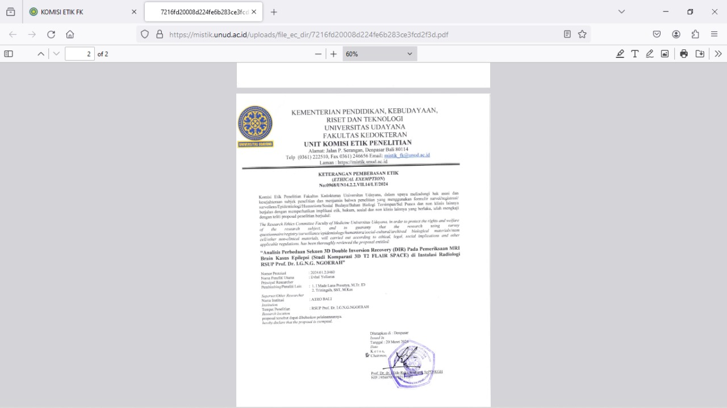

1. Surat Penelitian

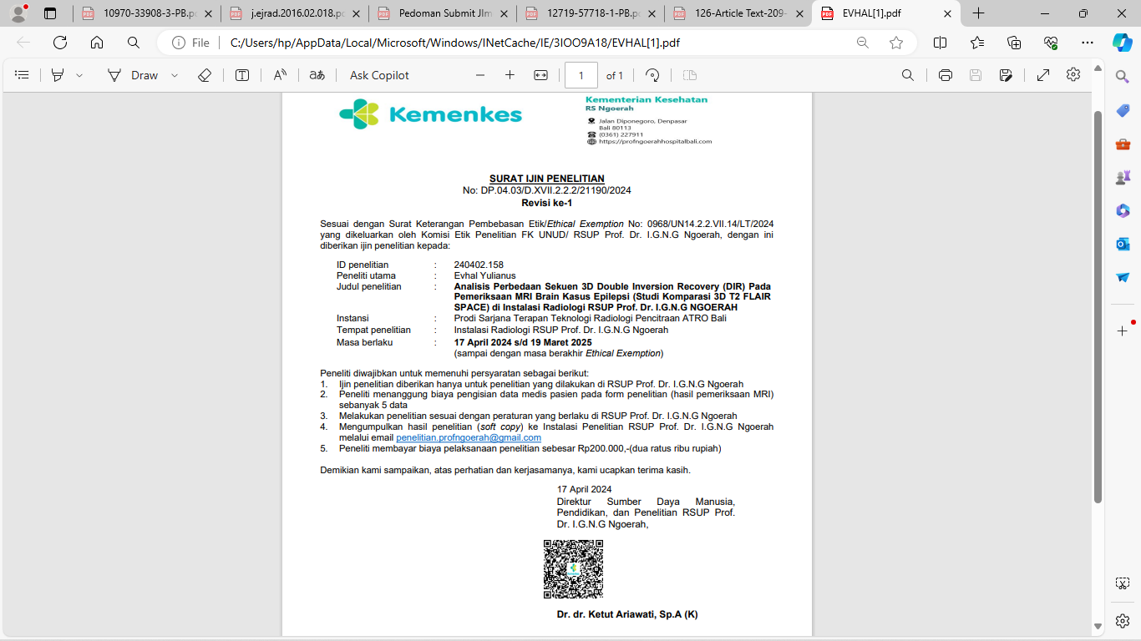

1. Hasil Data Roi Pasien

Pasien 1 Sekuen 3D Double Inversion Recovery (DIR) dan T2 FLAIR SPACE

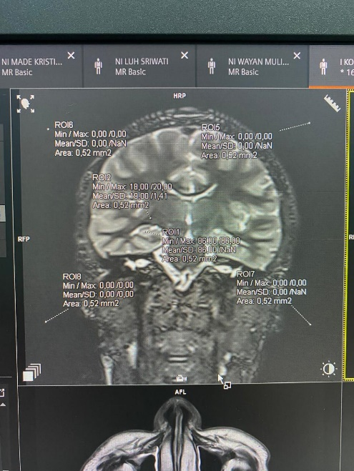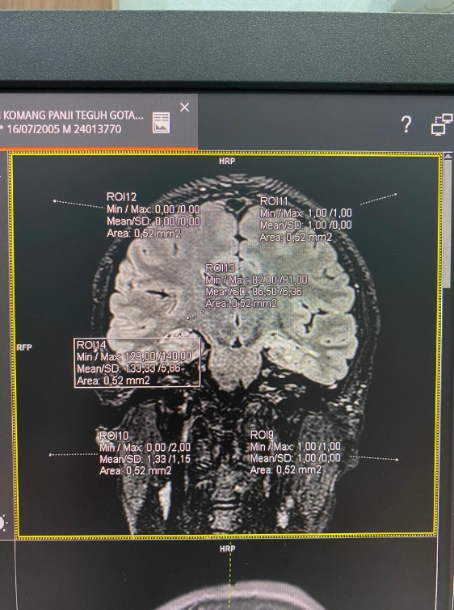

Pasien 2 Sekuen 3D Double Inversion Recovery (DIR) dan T2 FLAIR SPACE

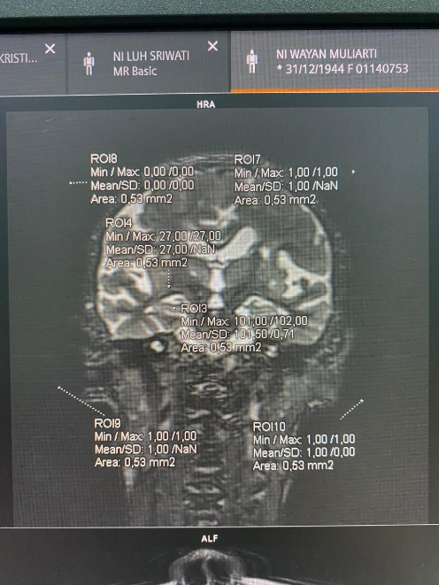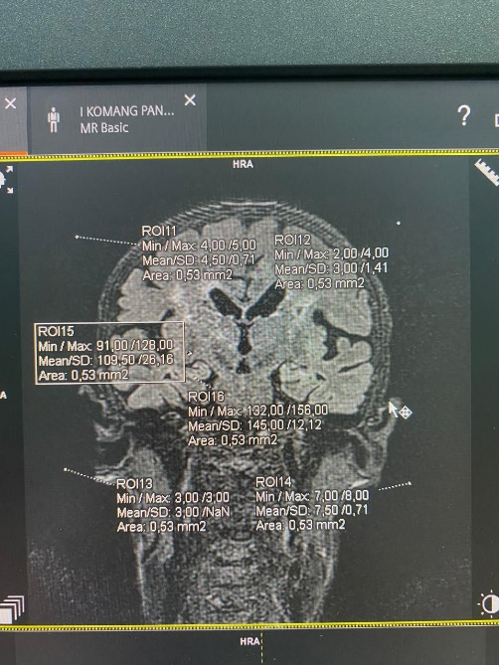

Pasien 3 Sekuen 3D Double Inversion Recovery (DIR) dan T2 FLAIR SPACE

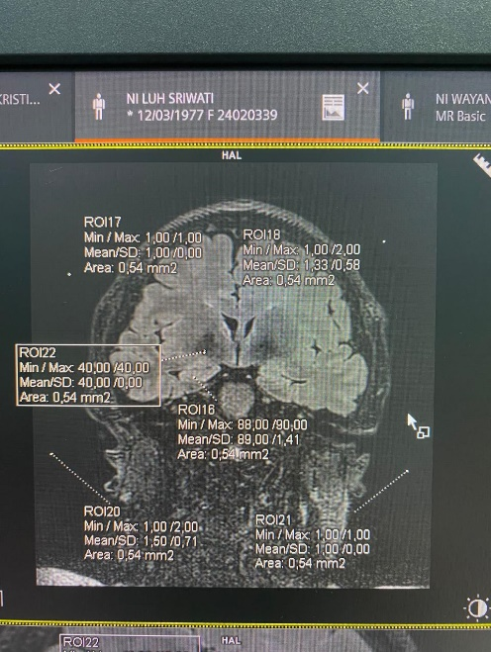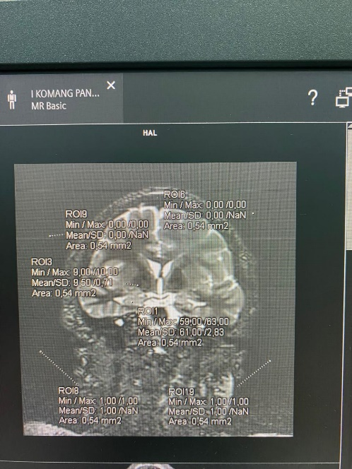

Pasien 4 Sekuen 3D Double Inversion Recovery (DIR) dan T2 FLAIR SPACE

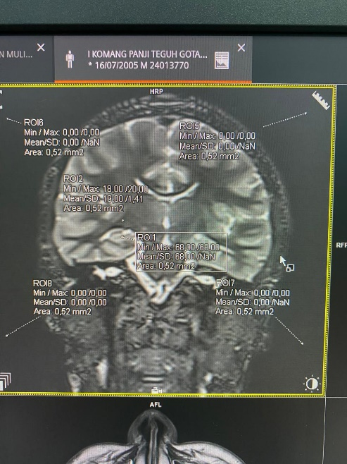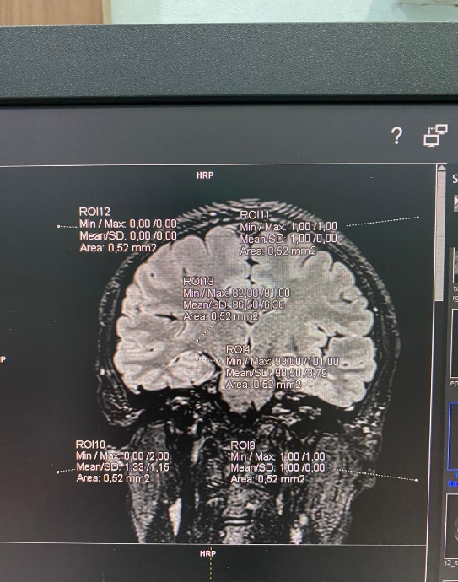

Pasien 5 Sekuen 3D Double Inversion Recovery (DIR) dan T2 FLAIR SPACE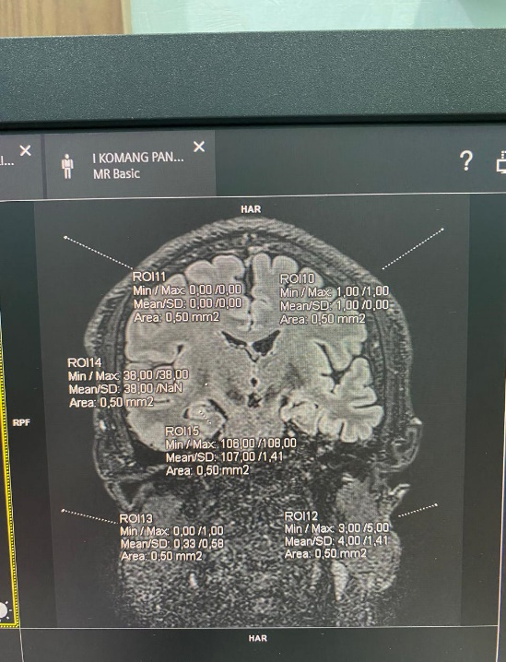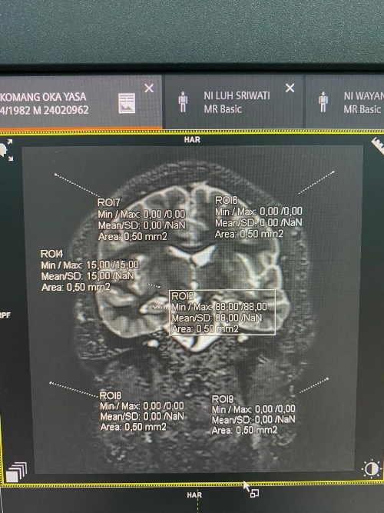

1. Hasil Uji SPSS 26

|  |  |  |  |  |  |  |
| --- | --- | --- | --- | --- | --- | --- |
| **Tests of Normality** | | | | | | |
|  | Kolmogorov-Smirnova | | | Shapiro-Wilk | | |
| Statistic | df | Sig. | Statistic | df | Sig. |
| Double Inversion Recovery | .231 | 5 | .200* | .850 | 5 | .195 |
| T2 FLAIR SPACE | .364 | 5 | .029 | .721 | 5 | .016 |

1. Uji Normalitas
2. Uji Wilcoxon

|  |  |  |  |  |
| --- | --- | --- | --- | --- |
| **Ranks** | | | | |
|  | | N | Mean Rank | Sum of Ranks |
| T2 FLAIR SPACE - Double Inversion Recovery | Negative Ranks | 5a | 3.00 | 15.00 |
| Positive Ranks | 0b | .00 | .00 |
| Ties | 0c |  |  |
| Total | 5 |  |  |

|  |  |
| --- | --- |
| **Test Statisticsa** | |
|  | T2 FLAIR SPACE - Double Inversion Recovery |
| Z | -2.023b |
| Asymp. Sig. (2-tailed) | .043 |
| a. Wilcoxon Signed Ranks Test | |
| b. Based on positive ranks. | |

1. Data Descriptive

|  |  |  |  |
| --- | --- | --- | --- |
| **Descriptives** | | | |
|  | | | Statistic |
| Double Inversion Recovery | Mean | | 63.0000 |
| 95% Confidence Interval for Mean | Lower Bound | 48.0936 |
| Upper Bound | 77.9064 |
| 5% Trimmed Mean | | 63.1389 |
| Median | | 67.0000 |
| T2 FLAIR SPACE | Mean | | 33.4180 |
| 95% Confidence Interval for Mean | Lower Bound | 17.2881 |
| Upper Bound | 49.5479 |
| 5% Trimmed Mean | | 34.1994 |
| Median | | 38.9900 |