RELATIONSHIP OF INFECTIOUS DISEASES TO THE NUTRITIONAL STATUS OF TODDLERS DURING THE COVID-19 PANDEMIC
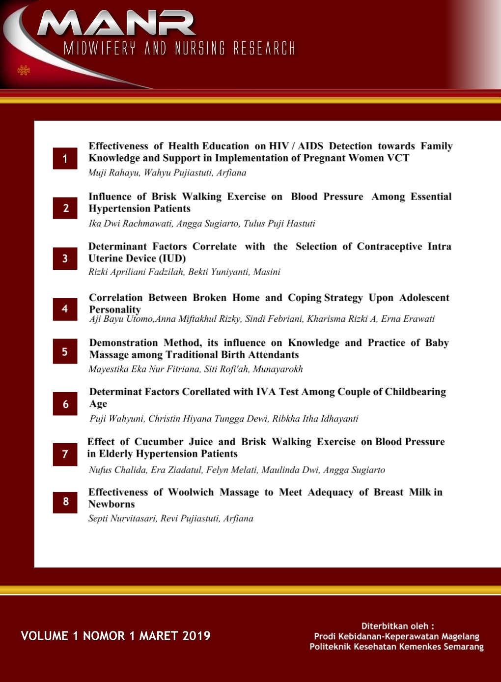

Rini Dwi Mulyani¹⁾ Nuril Nikmawati²⁾ Riska Ismawati Hakim³⁾ Fatma Hidayah⁴⁾
Email : rini.dwimulyani@gmail.com

ABSTRACT

Backgroud: Infectious diseases and nutritional intake are the main factors that affect nutritional status, especially during childhood. The results of the 2018 Riskesdas in Indonesia, the prevalence of underweight/bad nutrition problems was 17.7%, and stunting reached 30.8%. The COVID-19 pandemic has had a significant impact on the health system and the economy. Children under the age of 5 are very vulnerable to infectious diseases such as malaria, pneumonia, diarrhea, HIV and tuberculosis.
Methods: The design of this research is cross sectional. The sampling technique is simple random sampling, with a sample size determined by the slovin formula of 220 samples.
Result: The majority of respondents are children under five with a diagnosis of infectious lung disease of 179 (81.4%). The results of the analysis showed that there was a relationship between pulmonary infection and nutritional status of children under five at the Balkesmas Magelang Region, with a Z value of 11,432a with a significance value of 0.003 (< 0.05).
Conclusion: There is a relationship between infection diseases and nutritional status of children under five at Balkesmas Magelang Region

Keyword: Infectious disease, nutritional status, toddlers

¹Balkesmas Wilayah Magelang, Jawa Tengah, Indonesia
Jl. Jenderal Sudirman no.46B, Magelang Jawa Tengah, Indonesia
²Department of Nursing, Health Polytechnic of Semarang, Indonesia
Jl. Tirto Agung Pedalangan Banyumanik, Semarang, Jawa Tengah, Indonesia
³STIKES Guna Bangsa Yogyakarta, Indonesia
Jl. Padjajaran, Condong Catur, Depok, Sleman, DIY, Indonesia
⁴IBI Kota Magelang, Jawa Tengah Indonesia
Jl. Perintis Kemerdekaan, Magelang, Jawa Tengah, Indonesia

Received: written by editor; Revised: written by editor; Accepted: written by editor
(date of submission, 10pt)

Backgroud.
In developing countries such as Indonesia, infectious diseases and nutritional intake are the main factors that affect nutritional status, especially in children under 5 years old (toddlers). Infectious diseases are one of the factors that affect changes in nutritional status. Infectious diseases occur because of the interaction between the disease agent, the host, and the environment. Many diseases reduce nutritional status, but on the other hand, low nutritional status is also known to make individuals more susceptible to certain diseases and more serious diseases (Schneider, 2021).
The results of the 2018 Riskesdas in Indonesia, the prevalence of underweight/bad nutrition problems was 17.7%, and stunting reached 30.8%. This figure shows that public health problems are in the moderate level category for nutritional problems with the weight/age index being in the 20-29% range, while short/very short status with the body lenght/age index are in the high level category because they are in the 30-39 range. % (Indonesian Health Profile, 2019). In Central Java alone, the prevalence of malnutrition is 3.1% and malnutrition is 13.7%. Nutritional status indicators based on the weight/age index provide an indication of general nutritional problems. This indicator does not provide an indication of chronic or acute nutritional problems because body weight is positively correlated with age and height. Low weight/age indicators can be caused by being short (chronic nutritional problems) or suffering from diarrhea or other infectious diseases (acute nutritional problems) (Par'i, 2017). The COVID-19 pandemic has had a significant impact on the health system and the economy. Malnutrition in children, including underweight, is expected to increase as a result of sudden declines in household income, food insecurity and disruption of the health care system (Sharika, 2022).
In general, premature birth, pneumonia, diarrhea, and malaria are the leading causes of death in children under 5 years of age. Children under the age of 5 years are very vulnerable to infectious diseases such as malaria, pneumonia, diarrhea, HIV and tuberculosis (Unicef, 2020). Infectious diseases that often occur in children under five include acute respiratory infections or ARI. The prevalence of ARI under five in Indonesia is 7.8%, while in Central Java it is 9.7% (Riskesdas 2018), the prevalence of pneumonia in toddlers is 2.1%, while in Central Java it is 2.1%. The prevalence of pulmonary TB in Indonesia based on a doctor's diagnosis history according to the characteristics of age <1 year is 0.1%, age 1-4 years is 0.3%.
According to research by Carolin et al (2020), under-nutrition status in toddlers occurs because toddlers have suffered from ARI (Acute Respiratory Infection) and diarrhea that arise due to unfavorable environmental conditions and poor food intake. The nutritional status of children under five can be disturbed due to infectious diseases. Infectious diseases make toddlers do not have a good appetite. Food that is contaminated by germs can interfere with the absorption of nutrients. Wahyu et al, (2020.Based on this background, the authors are interested in conducting research on "The relationship between the nutritional status of children under five and respiratory tract infections during the COVID-19 pandemic at Balkesmas Magelang Region".

Methods.
This type of research is analytic research with cross sectional design. This research was conducted in April - May 2022 at Balkesmas Magelang Region. The sampling technique in this study used simple simple random sampling with the help of Microsoft Excel, with the inclusion criteria in this study were children aged 0-60 months who visited Balkesmas with complete nutritional status data recorded in the patient's medical record. The sample size is determined by the slovin’s formula, the results are 220. Analysis with the chi square correlation test with a significance level of = 0.005.

Result.
- Characteristics of infections diseases in toddlers at Balkesmas Magelang Region
respiratory tract infections | N | %
respiratory tract infections | 179 | 81.4
Non respiratory tract infections | 41 | 18,6

- Distribution of the frequency of respiratory tract infection disease categories among under-five respondents at Balkesmas Magelang Region

respiratory tract infections | N | %
TBC  Bronchitis  Pneumonia  ARI | 53  25  20  81 | 29.6  14.0  11.2  45.3

- Distribution of the frequency of the category of non-respiratory tract infections in under-five respondents at the Magelang Regional Health Center
non-respiratory tract infections | N | %
Allergic bronchitis | 38 | 92.7
asthma | 3 | 7,3

- Characteristics of the nutritional status of children under five based on the weight of the respondents at Balkesmas Magelang Region
nutritional status | N | %
severely underweight | 16 | 7,3
underweight | 10 | 18,2
normal | 164 | 74,5

- Analyzing the relationship between the nutritional status of children under five and lung infections in children under five at Balkesmas Magelang Region
Category | nutritional status |  |  | Total
Category | severely underweight | underweight | Normal
respiratory tract infections | 16 (7,3%) | 38 (17,3%) | 125 (56,8%) | 179 (81,4%)
non-respiratory tract infections | 0 (0,0%) | 2 (0,9%) | 39 (17,7%) | 41 (18,6%)
Total | 16 (7,3%) | 40 (18,2%) | 164 (74,5%) | 220 (100%)

- Discussion
The results of the analysis showed that the majority of respondents who visited the child patient at Balkesmas Magelang area were toddlers with a diagnosis of acute respiratory tract infection (ARI). This is in line with the research by Virgo (2022) which showed that most of the toddlers experienced frequent ARI occurrences, namely 59 toddlers (62.8%). The results of cross tabulation between both respiratory tract infections and non-respiratory tract infections indicate that the majority of respondents have good nutritional status. This is in accordance with Puspitasari (2020) which states that toddlers suffering from infectious diseases have normal nutritional status. This can happen because the pain experienced is not prolonged and the immune system is stable. In line with the research of Wahyu et al, (2020), toddlers who have good nutritional status have suffered from infectious diseases. This can happen due to good parenting and food availability. Toddlers have a good diet so that even though they have suffered from infectious diseases, their nutritional status remains normal.
The test results show that there is a relationship between pulmonary infectious disease and the nutritional status of children under five at Balkesmas Magelang Region. These lung infectious diseases include tuberculosis, ARI, pneumonia, bronchopneumonia, bronchitis. This is in accordance with Syarifa's (2021) research which shows that there is a significant relationship between a history of infectious disease and the nutritional status of children under five. Based on the results of Syarifa's research, it showed that respondents who had a history of infectious diseases and were hospitalized 3-4 times could cause malnutrition in toddlers as many as 37 people (68.4%). The results of Elisabeth's research (2021) also prove that a history of infectious diseases such as ISPA, Diarrhea, Worms, DHF is still the cause of nutritional status problems in toddlers, decreased appetite in children due to discomfort they experience, so that nutrient input is reduced even though children need nutrients. more, especially to replace body tissue damaged by disease germs.
Frequent and prolonged childhood illness can cause loss of appetite, absorption, metabolic disorders, and behavioral changes, which in turn can affect the nutritional status of a child. On the other hand, poor nutritional status can predispose children to illness or prolong the duration of recovery. The incidence of infection will directly affect the metabolism of nutrients in the body including inhibiting the absorption of nutrients, then the incidence of infection in children will affect the child's appetite to be less so that both of these things will have an impact on the nutritional status of children (Millward, 2017).
Intracellular parasites not only take advantage of the existing nutrients and cellular energy production systems within the cell, but also further encourage the cell to actively provide its nutrients. Poor nutritional status is associated with a weak response to sodium gluconate chemotherapy and decreased serum levels of metal matrix metalloproteinase 9 (MMP9), a cytokine that is negatively correlated with disease progression (Yang, 2021). Studies in tuberculosis patients have also shown that body composition can change due to changes in protein, fat, and micronutrient metabolism. Immune dysfunction is also believed to be the cause of the strong association between diabetes and tuberculosis. This interaction has significant consequences in individuals with a high incidence of malnutrition, diabetes mellitus, and latent tuberculosis infection.
Conclusion. Analysis of the relationship between pulmonary infectious disease and the nutritional status of respondents at the Balkesmas Magelang Region. The statistical test results showed a Z value of 11,432a with a significance value of 0.003 (< 0.05) Ha accepted and Ho rejected. This indicates that there is a relationship between pulmonary infection and nutritional status. toddlers at Balkesmas Magelang Region. It is important to ensure that children are raised with good parenting and nutrition patterns, as well as maintaining a healthy environment so that children are protected from infectious diseases that will have an impact on poor nutritional status. Parents are expected to further increase nutritional knowledge in order to achieve good nutritional status of toddlers, and always monitor the nutritional status of toddlers carefully.

Referencess

Carolin, B. T., Saputri, A. R., & Silawati, V. (2020). Analysis of Factors Affecting the Nutritional Status of Toddlers (12-59 Months) At Puskesmas Sukadiri, Tangerang Regency 2018. Science and Culture, 41(66)
Elisabeth Gladiana Cono, Maria Paula Marla Nahak, Angela Muryati Gatum. 2021. The Relationship between History of Infectious Diseases and Nutritional Status in Toddlers Age 12-59 Months at the Oepoi Public Health Center, Kupang City. CHMK HEALTH JOURNAL VOLUME 5, NOMOR 1 JANUARI 2021 236

Yang, Fang, Yang, Yi, Zeng, Lingchan, Chen, Yiwei, Zeng, Gucheng. 2021. Nutrition Metabolism and Infections. September 2021 - Volume 3 - Edisi 3 - hal 134-141. https://journals.lww.com/imd/Fulltext/2021/09000/Nutrition_Metabolism_and_Infections.4.aspx
Kementerian Kesehatan RI. 2019. Indonesian Health Profile. Jakarta: Kemenkes RI
Menteri Kesehatan Republik Indonesia. 2020. PERATURAN MENTERI KESEHATAN REPUBLIK INDONESIA Nomor 2 tahun 2020. About Child anthropometric standards

Millward DJ. Nutrition, infection and stunting: the roles of deficiencies of individual nutrients and foods, and of inflammation, as determinants of reduced linear growth of children. Nutr Res Rev 2017;30
Pane, Putri Yunita. Anaria. Aritonang, Eveline Suryati. 2022. Differences in Nutritional Status in Toddlers Before and After the Covid-19 Pandemic. Jurnal Penelitian Perawat Profesional, Vol 4No 1, Februari 2022, Hal 7-16
Par’I, Holil M, dkk. 2017. Nutritional Status Assessment. Jakarta. Kemenkes RI.
Syarifa Amalia. 2021. Studi Mengenai Status Gizi Balita. Jurnal Kebidanan Vol 7, No1, Januari 2021: 131-138.
Schneider Eric B. 2021.The effect of nutritional status on historical infectious disease morbidity: evidence from the London Foundling Hospital, 1892-1919. Received 13 Jul 2021, Accepted 14 Nov 2021, Published online: 10 Jan 2022. https://doi.org/10.1080/1081602X.2021.2007499
Sharika Nuzhat, SM Tafsir Hasan, et all. 2022. Health and nutritional status of children hospitalized during the COVID-19 pandemic, Bangladesh. Bull World Health Organ. 2022 Feb 1; 100(2): 98–107. Published online 2021 Oct 20. doi: 10.2471/BLT.21.285579. https://www-ncbi-nlm-nih-gov.

UNICEF. https://www.unicef.org/indonesia/id/kesehatan dikutip pd taggal 12 April 2021 jam 10.00
Wahyu, F. D., Triandhini, R. L. N. R., & Yalmav, S. R. (2020). Relationship of Nutritional Status with Incidence of Infection in Getasan District. Muhammadiyah Nursing, 5(1), 63–69

Yustisia Y, Anmaru R, Laksono B. The Influencing Factor Analysis of Stunting Incidence in Children Aged 24-59 Months at Kedung Jati Village. Public Heal Perspect J 2019;4(2):116–21

